- Due Oct 18by 12:59am
- Points 75
- Submitting a text entry box, a website url, a media recording, or a file upload
- File Types doc and docx
- Available after Oct 10 at 1am
The following two assignments has prepared you for success with this week's Kaltura video face-recorded interview (5-8 minutes max). Please follow the instructions:
Week 2: Listen to the Career Services live lesson recording https://devry.webex.com/devry/lsr.php?RCID=657429db46c43f949ffad87aa8ef6d2a
Week 6: Mock Interview Questions & Responses Assignment
  - Your complete Target Job Description Ad (screenshot/snipping tool)
  - Create a professionally dressed video interview recording using Kaltura Capture to record your responses to the following:
Introductory Questions (this is a five-part question)
Introduce yourself to the hiring manager. Share your professional brand message. Explain why you are interested in the position you chose for this assignment (be specific) and why you believe you are a strong fit. Share the value you will bring to this position and organization.
General Interview Questions (Select 2)
  - What are your strengths?
  - What areas are you working to improve?
  - What motivates you to get the job done?
  - Share how previous supervisors and colleagues would describe you.
  - What do you see as the biggest challenge you would need to overcome in this position within your first 90 days?
  - How would you rate your organizational skills?
  - How do you respond to stressful situations?
  - What is your greatest accomplishment?
  - Where do you see yourself in 5 years?
  - Why should we hire you?
Behavioral Interview Questions (Select 2)
  - Describe a time when you were creative in solving a problem.
  - Describe a time when you worked effectively under pressure.
  - Tell me about a time when you persuaded a colleague to see things your way.
  - Tell me about a time when you had to resolve an issue with a coworker.
  - Describe a time when you were forced to make an unpopular decision.
  - Describe a time when you were disappointed in your own behavior.
  - Tell me about a time when you had to deal with an irate customer.
  - Tell me about a time when you were not able to complete a project on time.
  - Describe a time when you set your sights too high.
  - Describe a time when you delegated a project successfully.
Final Question: After conducting research on the company for the position you chose, share one question you want to ask the hiring manager that you cannot find the answer to on their website or on LinkedIn.
You will need to dress appropriately for this recording as if you were really going to a professional interview.
Use the required and appropriate APA template located in the FILES and submit for grade by the Sunday deadline.
  - Submit the shareable Kaltura Video Face-Recorded Interview link in the APA word document.
  - Submit the Complete Job Description Ad for which you were interviewing in the APA word document.
A shareable link will be in this format: https://lms.devry.edu/lms/video/player.html?video=1_xxxxxx.

Rubric
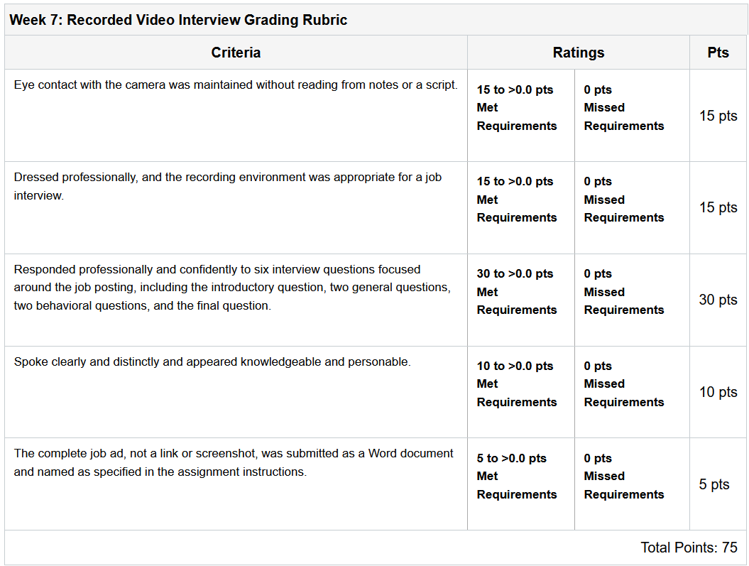

SCENARIO: You just received a phone call from Human Resources at the company where you interviewed last week! Congratulations! But...
When evaluating a job offer, share your process. Is this company a good fit for you? Have you researched as much as you can to find out about the organization's leadership and its mission, reputation, values, working environment, and culture? What do you know from the interview about your potential boss's style of management? Is it compatible with your preferred style as an employee? Does the salary that HR is offering meet your needs? What about the benefits package? Are the work hours compatible with your family obligations?
You really have to look back at the job, I take care of two teenagers and I know others have children also. They often pull you away from work because of medical and other things. I also have elderly parents which need someone to watch over them; does the job understand and willing to work with schedules of appointments and such? Honestly, I didn't do any research on the company. The salary listed in the application is above the average for my area, yet competitive for the area in which the job is posted for.
What motivates you to get the job done?
There is a lot of things that can motivate a person to get the job done, especially on time and with success. Networking and information technology have always come naturally, I have a love for the details, physically putting things together and seeing it work afterward. So I would have to list the pride of seeing something successfully completed and family has to be my biggest two motivations.
Describe a time when you delegated a project successfully.
I worked a couple of years as a network engineer within the central US, with so many offices; it was impossible not to have projects overlap. Then managing breaking hardware and software on top of that. You had to trust the people you worked with and keep communication open. While it might be possible for projects, a person has a physical limitation of not being a be multiple locations at the same time. We used to consider those co-projects, I could be overseeing a project in Denver, Colorado, and have a secondary working remotely to help me on the same project. While he is also overseeing a project in Houston, Texas, and I was his secondary working remotely when he needed. This did multiple things, at any given point. More than one person was current on the project, if something happened, you automatically had a fill-in and who could take over, and finally, you also had a second set of eyes that could oversee your work and keep you and check.

- Take a moment to reflect on the many projects, certifications, courses, and teams you have been a part of. Which of these documents from your life's accomplishments could you add to your LinkedIn profile page? In a single paragraph describe your role and experience.
I have been in information technology since 2002, over the years I have been included in many projects that are worthy of resume mention. Two of them that I commission in detail if asked was working for TRC Environmental, I was the central United States information technology network, engineer. I covered all of the central US offices, 12 of them, and supported around 800 employees. We were an international company, and while I traveled for projects all over the country. I and one other was directly responsible for these offices in the central US. One of two projects was the deployment of Riverbed devices, to all the offices under my supervision. The second project was the merger and relocation of three Houston offices into one office. That included overseeing the planning and implementation of the network infrastructure, phone system, physical migration of the servers and desktops, and working with others such as electricians and communication representatives to coordinate each level of the project.

I could probably write a 4 to 5-page report on these projects, it seems like day and night. The type of work that I used to do vs. the work that I do now. My supervisor back in gave a snotty-nosed kid a chance, and I ran with it. I have been fighting for several years, and one of the reasons why a return to school is so that I could get back into the field doing the work that I love. To realize how lucky I was back then, they only have a high school education and a few certifications.

- Adaptive Skills relate to your work style that helps you function as a good employee on a day-to-day basis. In your ebook, go to Exercise 2.3 (p. 39) and select ONE adaptive skill. In a single paragraph demonstrate the application with a real work example. DO NOT DEFINE THE TERM!
There are many self-skills on the list that I could select. Yes, I can demonstrate real work experience with this one and I could also apply it to my current college career. There are many skills and traits that I have learned throughout the years, one of my very first jobs as a supervising system administrator were ex-military. He ran the business and his employees the if you were not 15 minutes early, then you were 15 minutes late. Because of this, and how we were required to bill clients I learned time and project management very well. At one point in my life. I carried around a notebook to which I kept track of my every move throughout the day, down to 15-minute increments. At any time, you can give me a date and a time, and I could tell you where I was and what I was doing. It not only covered me but made billing very easy. When I returned to the office in the afternoons or the next morning, I would use my notes to enter everything into my timesheet, and then our manager would go to and deal with the client. If a customer had a question about a bill, I could look it up in my notebook and give additional details or answer the client's questions.
1. From your personal resume, quantify ONE (1) skill that can be presented as an achievement statement rather than just simply listed as a task
Over the course of the last couple of years, working for several different managed service providers. I have seen setups that monitor the servers and systems on a customer and their infrastructure. One of the things I was exposed to was a networking monitoring system or NMS. There are several major ones out there like Prometheus, LibreNMS, OpenNMS, and NEMS. They all do the same thing in different ways, seeing that I chose LibreNMS since it had the most documentation and online videos. Since then, I have not only extended my knowledge on AWS EC2 instances but deployed a VPS hosting LibreNMS. It uses the internal AWS network to monitor my 19 other VPS servers and VPN connections to my customer's offices to monitor their equipment as well. I see a nice dashboard of all my resource usage and stats. Including emails and text messages when a device goes offline. There are even some emails that goes out to clients when their printer levels reach below a certain percentage. So, this was a big accomplishment! For a single person to take on, not much in development but the layout, planning, and deployment of the project and all the included details.
2. Review the list of Resume Do's and Don'ts in Chapter 5 and share ONE (1) point in critiquing your own resume. Go to the page of the ebook and provide the actual bullet content. THEN your personal example should follow.
There was a couple with which I was able to edit my resume.
- The first one was removing my full address at the top and replacing it with just my city and state. No one needs to know my home address through the interview process, it’s a large privacy issue.
- Don’t go over 2 pages unless you are an executive or you know your profession calls for this. In that case, considering making a curriculum vita. Curriculum vita is used primarily in academic fields, outline credentials. Each field has its own standard.
  - The second one was loading too much information onto my resume, my wife went over my resume while she was completing college and one of the big things was cramming everything to one page. I will be extending it out where it doesn’t look so cramped.
- Do include honor societies within your major in your GPA that is 3.0 and higher.
  - The third one was adding clubs and honor societies. I am the vice-chairman of the DeVry Student Diversity, Equity, and Inclusion Council. Tonight, I realized it wasn’t listed on my resume. Neither was my GPA or Dean’s list.

- What is your TARGET DREAM JOB? My target dream job is a job that I’ve had in the past, network engineer. I started working in 2004, repairing computers. At that time, my title was just computer technician as I worked for different clients. We had a local engineering firm that got bought out by a national company. I will not name any names, but they held various contracts for the Department of Defense and Homeland security and did civil engineering and substation design at the time. There are no positions available within the company, especially in information technology. I was hired as a construction inspection technician, with the idea of one day a week I would spend in the field looking at various construction sites. This did not last long as I was frequently pulled into the office to take care of other things. In three years, I went from an IT guy who was hired to check construction sites to a network engineer over the central United States. While things in my life got complicated and I had to resign from the job, the position, and the work I was doing at the time. I think back daily about how much I enjoyed working for that company and doing that type of work. That must be my dream job, and to get back into use a similar position.
- Identify (1) cold and (1) kindly contact to interview about your TARGET DREAM JOB field/company. How might you reach out to them to conduct an informational interview? I’m not entirely sure if you would call this a cold contact, but I am associated on LinkedIn with the old CIO from the company I listed above. While he is no longer with the company, he is now the CIO of another company. We stay in contact. I have one you consider kindly contact; there is a local office to a telco company that does telephone systems, networking, and other information technology projects. In 2002 when I took my CompTIA A+, Matt was the teacher who taught me in the class. Eighteen years later, he is still teaching me different things, and I am currently working with them side-by-side on some projects.
- If allowed the informational interview, what goals do you target for yourself to feel satisfied? There are a lot of goals, and some could consider just bucket list items. One of the first things that come to mind is switching over to Pinterest and looking at my bucket list. However, I know that this is not very professional, and I do not consider Pinterest professional. A lot of people blurred the loans to retrain professional social media and personal. I try my best not to be one of those people in the previous position I had that I spoke about above. I was a salaried employee that could come and go as he pleased and work the hours that he needed to work. If I needed to take off for one of my kid’s doctors’ appointments, I could just come in late. The department understood that a lot of the work we did could not always be done during the typical 8 to 5 hours, primarily for this type of work that I did. I was not just a helpdesk; I maintained the servers and the active directory domain as a network engineer. I was seen more of a; you better be there when I call upon you, and your focus better is on your projects. Often, when I traveled across the country, going in and out of different offices was done after hours when the employees were not there, and I could shut down or restart the servers. I was fortunate to score that position at the time, and ultimately, that’s what I would love to get back to, a situation where my head is buried in server racks and networking equipment 18/24 hours a day.
Sorry about it being so long, I had a short soapbox episode while writing.
1. For your Target Dream Job, describe your professional strengths and make an argument for why they are important.
My dream job is close to Niral Patel, with the exception that I want to not just become the network tech but own the company also. I have been a network technician and network engineer; I want life back and to own my company as well.
- Troubleshooting network performance and connection issues.
- Implement and continue using network and system monitoring solutions (e.g.: performance monitoring of hardware, security monitoring, and backups.)
- Design systems incorporating network infrastructure, computer systems, and software.
- Working with other technicians and parties to effectively implement IT solutions to customers.
- I have 17 years of professional experience in networking, systems integration, cabling, and maintaining.
- I am CompTIA A+ certified and Microsoft Certified, Professional.
- Monitoring downtime and system uptime for customers and clients.
2. In what ways could you develop your brand to effectively market yourself?
One of the best ways is a professional profile site along with LinkedIn, along with other profiles on sites related to your career like GitHub, CareerBuilder, and Indeed. Attending job fairs and networking with people in your field in person and creating connections. Get your name in front of others within the same field you’re wanting to enter or move up in.

